Approach Notice
Team: ArcLight

1. Problem and Objective
Salary information is the single most decision-relevant attribute of a job posting, yet it is often hidden or coarse. Our goal is to predict whether an Analytics job posting falls in a high salary band using only characteristics that are always visible on the posting: role, location, experience and required skills.
Item | Definition
Target (high_salary = 1) | Salary band 15to25 or 25to50
Target (high_salary = 0) | Salary band 0to3, 3to6, 6to10 or 10to15
Task type | Binary classification on an imbalanced target
Platform | SAS OnDemand (SAS Studio); all steps in one reproducible script, seed 20261007

2. Solution at a Glance
The pipeline is fully implemented in SAS and runs end to end from raw CSVs to a saved, re-loadable model. Preprocessing and model selection are finished; the model has been scored on a held-out 20% test set.
Stage | Key decision
Data | 15,841 labelled Analytics job postings (from Analytics Jobs.csv); DataScience Jobs.csv used for a market-demand view
Class balance | 71.4% lower salary vs 28.6% high salary, handled with balanced class weights
Features | Role group, location group, capped experience, capped skill count and six skill flags
Dimensionality control | Top 20 roles and top 15 locations kept, the rest grouped as OTHER
Validation | 80/20 stratified split, then randomized stratified 5-fold cross-validation on the training part
Model search | Grid search (3 feature sets) plus randomized search (12 draws of feature set × cutoff)
Selection metric | Mean cross-validated F1 score
Hold-out result | Recall 73.7%, F1 0.646, balanced accuracy 76.0%, accuracy 77.0%
The flowchart on the next page shows how data moves through these stages.

3. End-to-End Pipeline
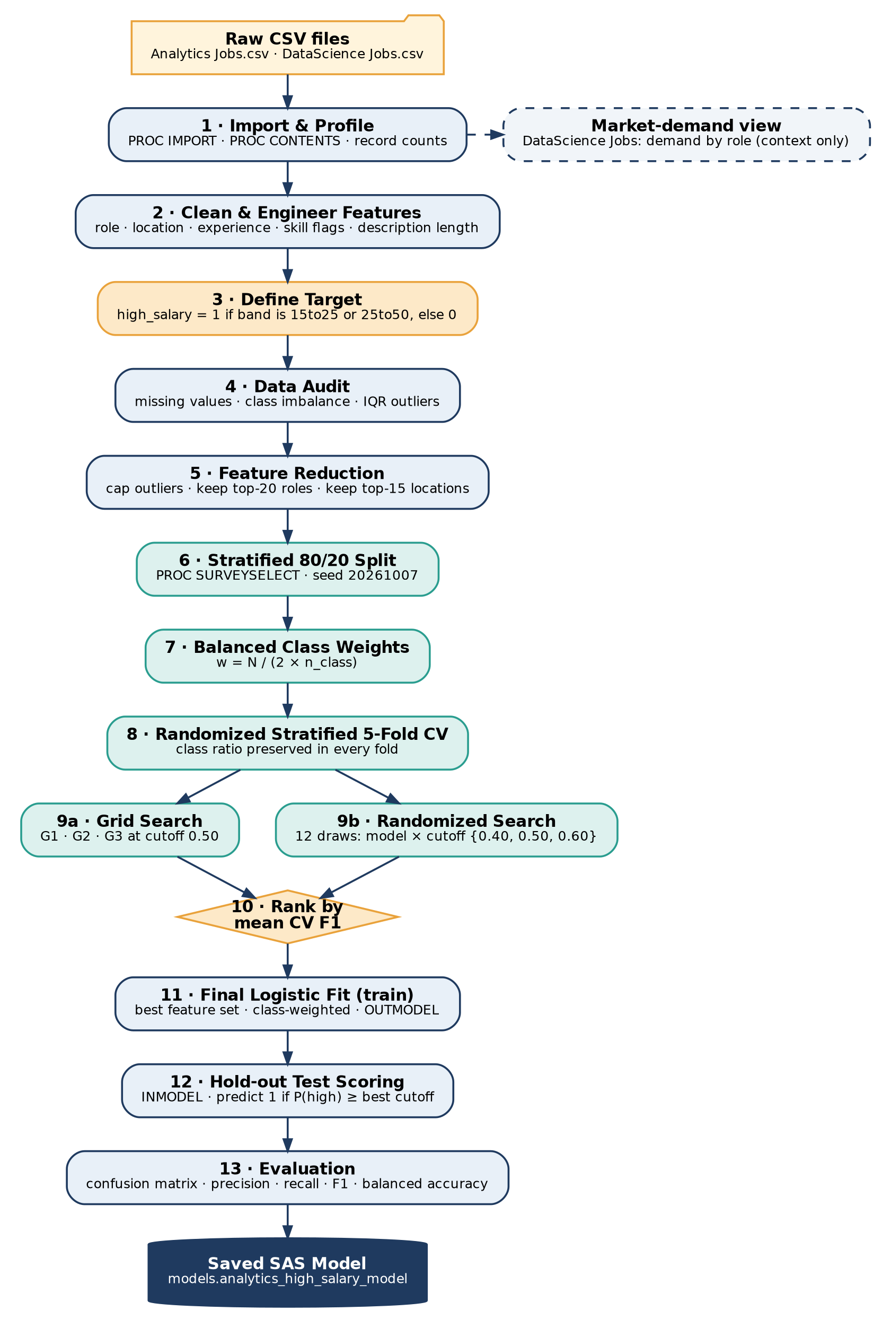
Figure 1. End-to-end pipeline, from raw CSV files to the saved SAS model.

4. Environment and Data
Raw files are stored in a SAS_Hackathon project folder in the SAS OnDemand home directory, with separate Raw_Data and Models folders. The script builds its paths from the home directory, so it runs unchanged on any account with the same layout.
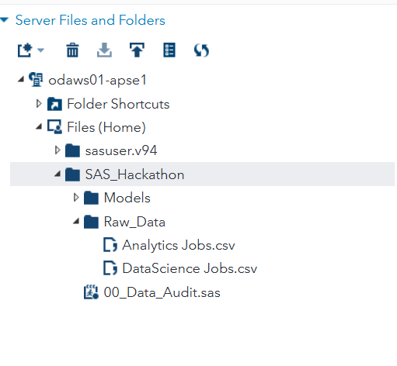
Figure 2. Project layout in SAS OnDemand: raw CSV inputs, a Models folder for the saved model, and the audit script.
Two sources, two roles. Analytics Jobs.csv carries the salary band and therefore feeds the classifier. DataScience Jobs.csv has numeric salaries and job counts, so we use it only to profile market demand by role. Business Analyst (32,843 jobs), Data Analyst (18,095) and Senior Business Analyst (14,115) lead demand, which tells us which role families the classifier must handle well.
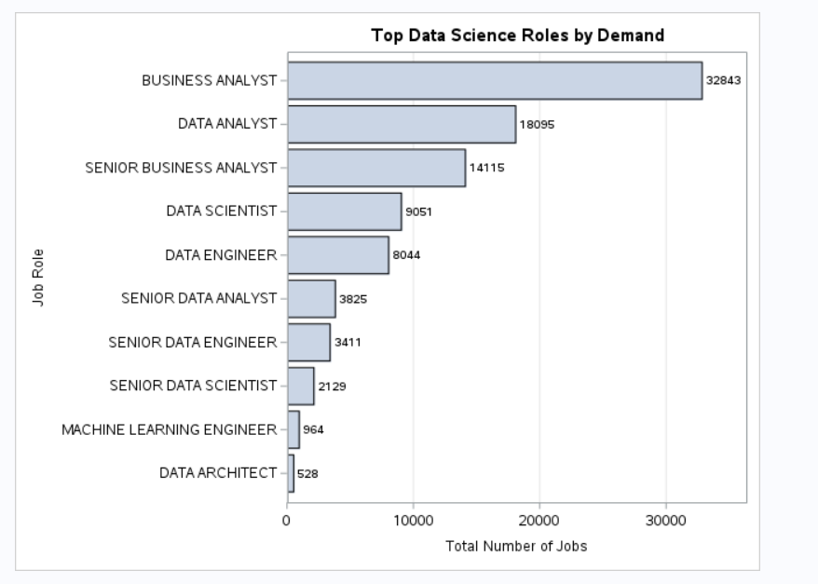
Figure 3. Top Data Science roles by total number of jobs (DataScience Jobs.csv).

5. Data Preparation and Feature Engineering
Every raw column is cleaned and converted into a numeric or low-cardinality categorical feature. Free-text fields are reduced to signals that are cheap to compute and easy to explain.
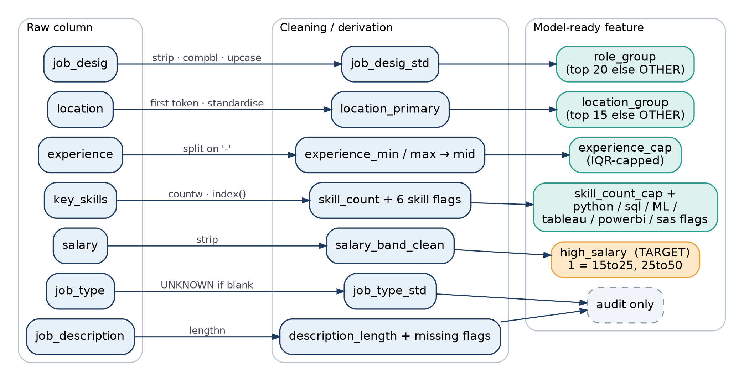
Figure 4. From raw columns to model-ready features. Teal = model inputs, amber = target, dashed = audit only.

5.1 Target and skill flags
Target definition and skill flags (excerpt)
if salary_band_clean in ("15to25","25to50") then high_salary=1;
else if salary_band_clean in ("0to3","3to6","6to10","10to15") then high_salary=0;
else high_salary=.;

skills_upper = upcase(strip(key_skills));
python_flag = (index(skills_upper,"PYTHON") > 0);
sql_flag = (index(skills_upper,"SQL") > 0);
machine_learning_flag = (index(skills_upper,"MACHINE LEARNING") > 0);
/* tableau_flag, powerbi_flag, sas_flag follow the same pattern */

5.2 Experience parsing
Experience arrives as a text range such as "2-5". We split it into minimum and maximum, treat a single value as both, and use the midpoint as the numeric feature.
Experience range to midpoint (excerpt)
experience_min = input(scan(strip(experience),1,'-'),best32.);
experience_max = input(scan(strip(experience),2,'-'),best32.);
if missing(experience_max) and not missing(experience_min)
then experience_max = experience_min;
experience_mid = mean(experience_min, experience_max);

Standardisation. Roles are trimmed, de-duplicated of extra spaces and upper-cased. Locations are reduced to the first city token, and aliases are merged (Bangalore to Bengaluru, Gurgaon to Gurugram). Blank job type or location becomes UNKNOWN instead of being dropped.

6. Data Audit

6.1 Missing values
Job Type is missing in 75.8% of postings and Job Description in 22.1%, while Designation and Location are complete and Key Skills is missing in only 0.006%. Because Job Type is mostly empty, it is kept only as an UNKNOWN-aware audit field and is not used in any candidate model. Missingness flags are stored so the effect can be revisited later.
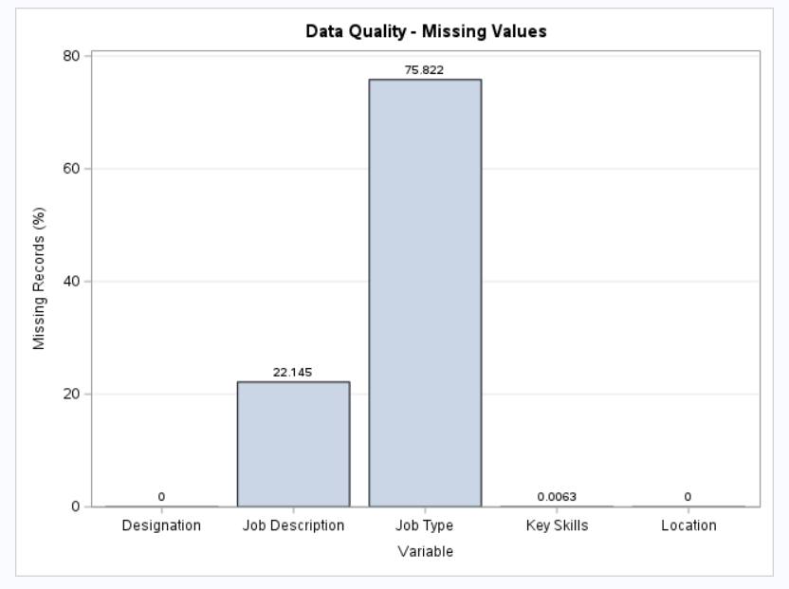
Figure 5. Percentage of missing records per variable.

6.2 Class imbalance
The six original salary bands are uneven, and after collapsing them into the binary target the split is 11,315 lower-salary vs 4,526 high-salary postings (71.4% / 28.6%). A plain classifier would drift toward predicting the majority class, so imbalance is handled explicitly with class weights (section 8).
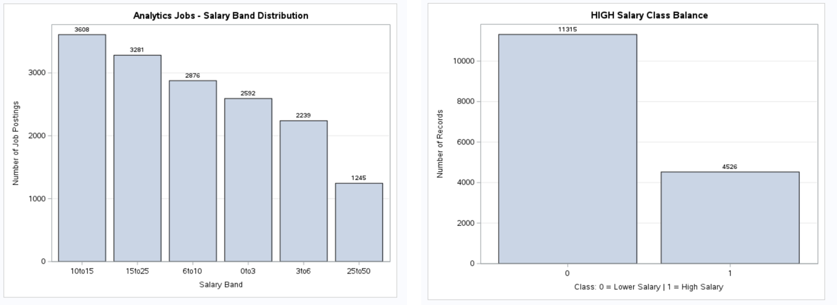
Figure 6. Left: original salary bands. Right: binary target after grouping.

7. Outliers and Feature Reduction

7.1 IQR outlier handling
Experience, skill count and description length were screened with the 1.5 × IQR rule. Instead of deleting records, flagged values are capped at the fence, so no training data is lost and extreme values cannot dominate the fit.
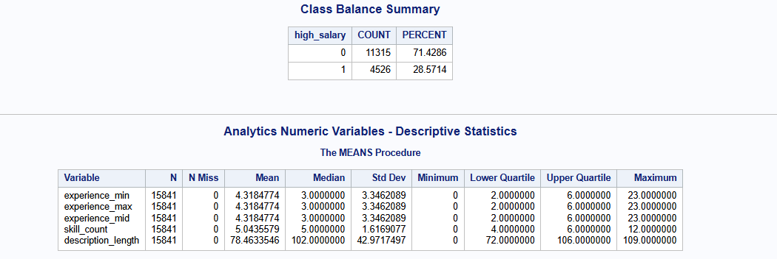
Figure 7. Class balance summary and descriptive statistics for the numeric variables.
Variable | Q1 | Q3 | Lower fence | Upper fence | Outliers flagged
Experience (years) | 2 | 6 | -4 | 12 | 318 (2.0%)
Skill count | 4 | 6 | 1 | 9 | 195 (1.2%)
Description length | 72 | 106 | 21 | 157 | 3,512 (22.2%)

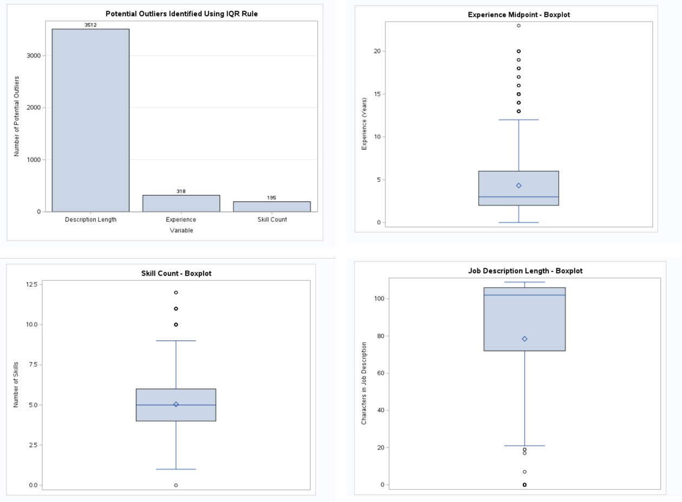
Figure 8. Outlier counts and boxplots for experience midpoint, skill count and description length.
Reading the evidence. Experience outliers are senior postings (13 to 23 years) and are genuine, so capping keeps them informative without letting them stretch the scale. The large description-length count is explained by empty or very short descriptions (22% are missing), so this variable is kept as a data-quality diagnostic rather than a model input.
IQR capping, shown for experience (skill count and description length follow the same pattern)
experience_lower = q1_experience - 1.5*experience_iqr;
experience_upper = q3_experience + 1.5*experience_iqr;

experience_cap = experience_mid;
if experience_mid < experience_lower then experience_cap = experience_lower;
else if experience_mid > experience_upper then experience_cap = experience_upper;

7.2 High-cardinality control
Job designations and locations have many rare values that would create sparse dummy columns. We keep the 20 most frequent roles and 15 most frequent locations and map everything else to OTHER, which keeps the model stable and the feature space small.

8. Splitting, Weighting and Validation

8.1 Stratified hold-out split
Data is split 80/20 with PROC SURVEYSELECT, stratified on high_salary so both parts keep the 28.6% positive rate. The 20% test set (3,168 postings) is untouched until the final evaluation.

8.2 Balanced class weights
Each training record receives a weight N / (2 × n_class). With roughly 9,050 lower-salary and 3,620 high-salary training records this gives weights of about 0.70 and 1.75, so both classes contribute equally to the fit.
Stratified split and class weights (excerpt)
proc surveyselect data=work.analytics_features_sorted out=work.train_test_sample
samprate=0.80 seed=&seed method=srs outall;
strata high_salary;
run;

%let weight_low = %sysevalf(&n_train_total / (2*&n_train_low));
%let weight_high = %sysevalf(&n_train_total / (2*&n_train_high));

8.3 Randomized stratified 5-fold cross-validation
Within each class, training records are shuffled with a fixed seed and dealt round-robin into five folds. Every fold therefore mirrors the class ratio, and the results are reproducible.
Fold assignment (excerpt)
by high_salary; /* sorted by class, then random order */
if first.high_salary then fold_counter=0;
fold_counter + 1;
fold = mod(fold_counter - 1, &kfold) + 1;

9. Model Search and Selection
The classifier is a logistic regression (PROC LOGISTIC, reference coding for categorical inputs, event = high salary). It is fast, interpretable and its probability output lets us tune the decision cutoff. We search over three nested feature sets and three probability cutoffs.
Config | Inputs | Idea
G1 | experience_cap, role_group | Baseline: seniority and job family
G2 | G1 + location_group | Adds the geographic pay effect
G3 | G2 + skill_count_cap + python, sql, machine learning, tableau, power bi, sas flags | Adds skill signals

Grid search evaluates G1, G2 and G3 at the standard 0.50 cutoff. Randomized search then draws 12 random combinations of feature set and cutoff (0.40, 0.50 or 0.60) to probe whether a different threshold helps the minority class. Every candidate is scored with the same five folds, and the winner is the one with the highest mean cross-validated F1.
Grid configurations and random search space (excerpt)
%grid_cv(config=G1, model_vars=experience_cap role_group);
%grid_cv(config=G2, model_vars=experience_cap role_group location_group);
%grid_cv(config=G3, model_vars=experience_cap role_group location_group
skill_count_cap python_flag sql_flag machine_learning_flag
tableau_flag powerbi_flag sas_flag);

do iteration=1 to 12;
model_number = rand("integer",1,3); /* G1, G2 or G3 */
threshold_number = rand("integer",1,3); /* cutoff 0.40 / 0.50 / 0.60 */
...
end;

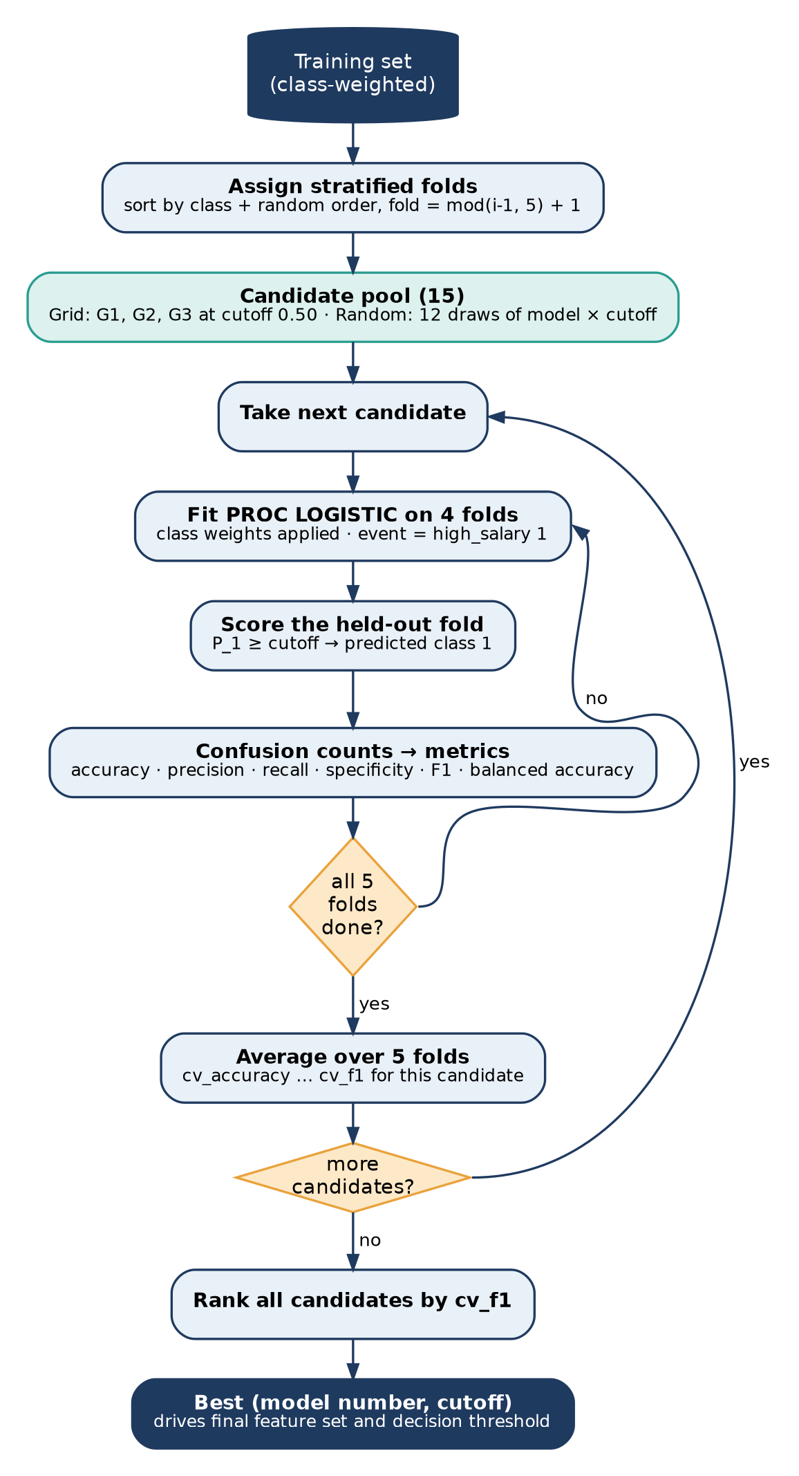
Figure 9. Cross-validated model search and selection logic.

10. Final Model and Hold-out Results
The selected feature set is refitted on the full training data with class weights and stored as a reusable SAS model data set. The test set is then scored from the saved model using the winning cutoff, which proves the model can be reloaded and used without retraining.
Final fit, save and hold-out scoring (excerpt)
proc logistic data=work.train_data outmodel=models.analytics_high_salary_model;
class role_group location_group job_type_std experience_group / param=ref;
model high_salary(event="1") = &final_vars;
weight class_weight;
run;

proc logistic inmodel=models.analytics_high_salary_model noprint;
score data=work.test_data out=work.final_test_scored;
run;

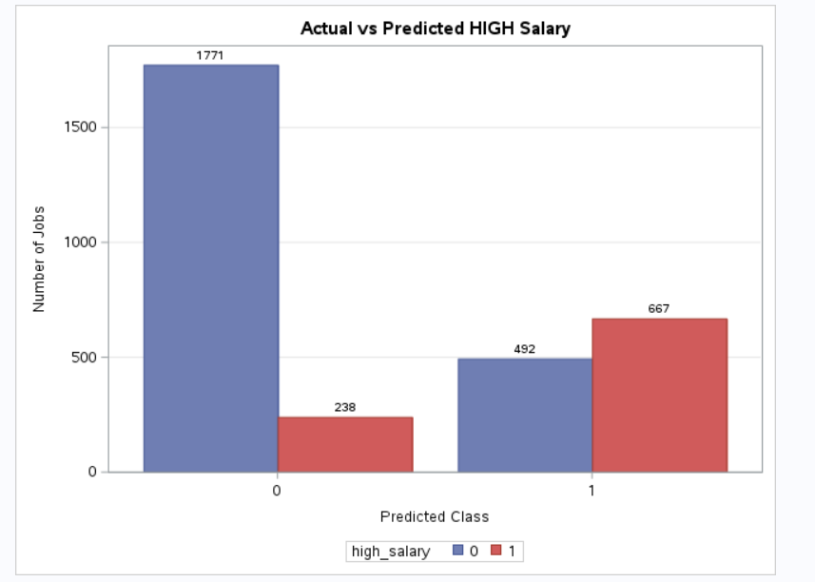
Figure 10. Actual vs predicted high-salary class on the 3,168 hold-out postings.

10.1 Confusion matrix
 | Predicted: lower | Predicted: high
Actual: lower | 1,771 (TN) | 492 (FP)
Actual: high | 238 (FN) | 667 (TP)

10.2 Metrics
Metric | Value | What it tells us
Recall (sensitivity) | 73.7% | Share of truly high-paying jobs the model finds (667 of 905)
Precision | 57.5% | Share of predicted high-paying jobs that really are (667 of 1,159)
F1 score | 0.646 | Balance of precision and recall; the selection metric
Specificity | 78.3% | Share of lower-paying jobs correctly left out (1,771 of 2,263)
Balanced accuracy | 76.0% | Average of recall and specificity; robust to imbalance
Accuracy | 77.0% | Overall share correct (2,438 of 3,168)

Interpretation. A naive model that always predicts lower salary would score 71.4% accuracy yet find none of the high-paying jobs. Our model reaches 77.0% accuracy while catching almost three quarters of them, which is the outcome class weighting and F1-based selection were designed to achieve.

11. UML Design
The script is procedural SAS, but its responsibilities map cleanly onto a small set of components. The diagrams below describe that logical design and the runtime behaviour.

11.1 Class diagram: data preparation
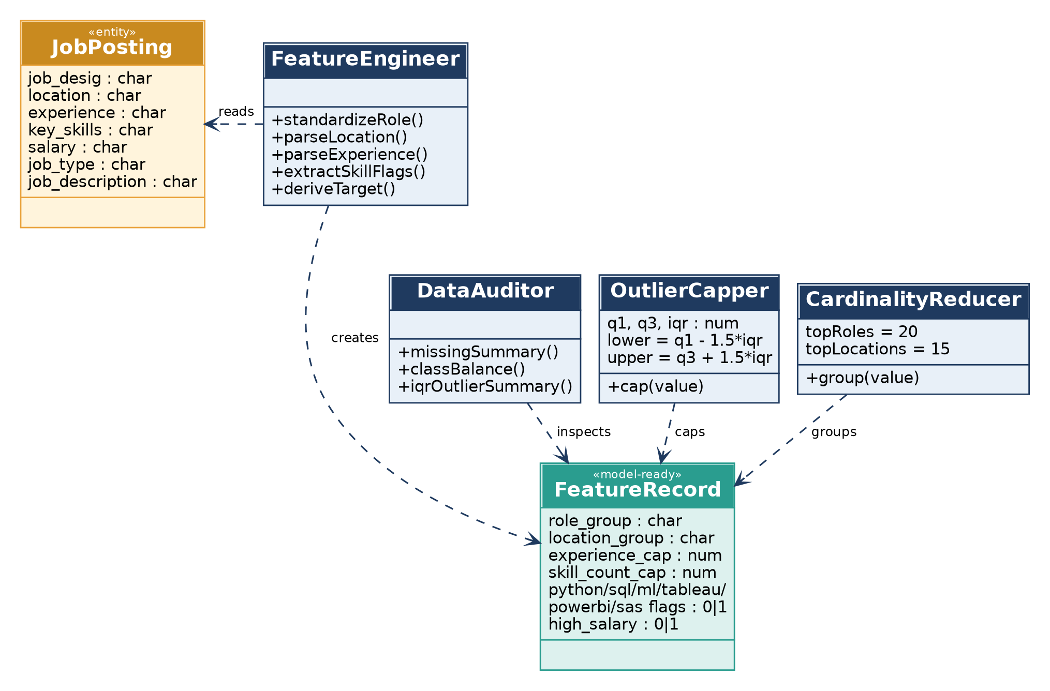
Figure 11. Logical classes for cleaning, auditing and preparing job postings.

11.2 Class diagram: modelling and persistence
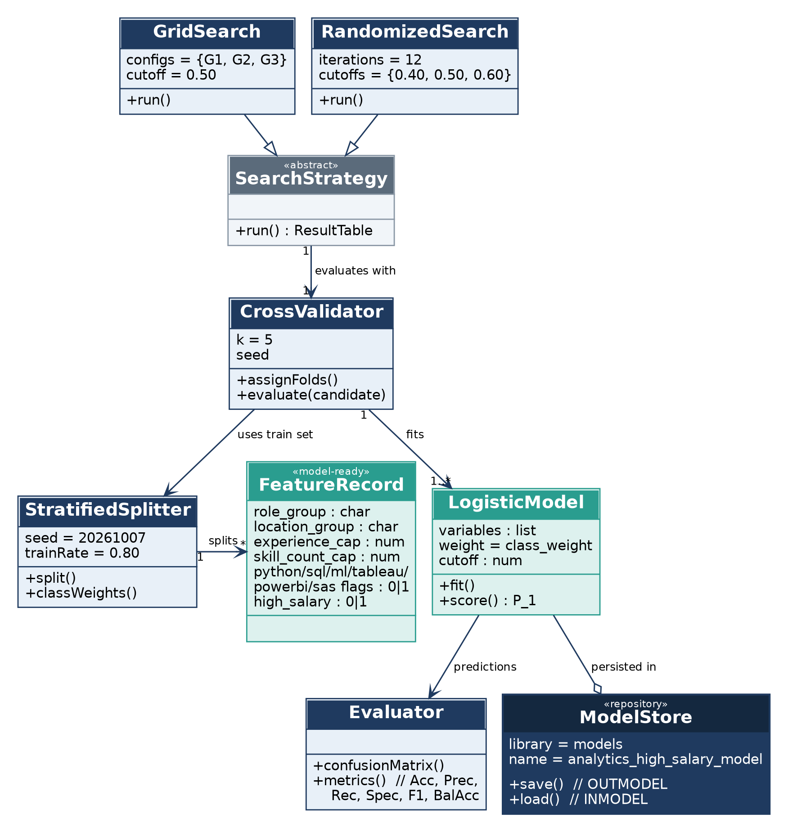
Figure 12. Logical classes for splitting, search, cross-validation, fitting, evaluation and storage.

11.3 Activity diagram: record-level processing
This shows what happens to a single job posting, including the decisions that discard, cap or regroup values.
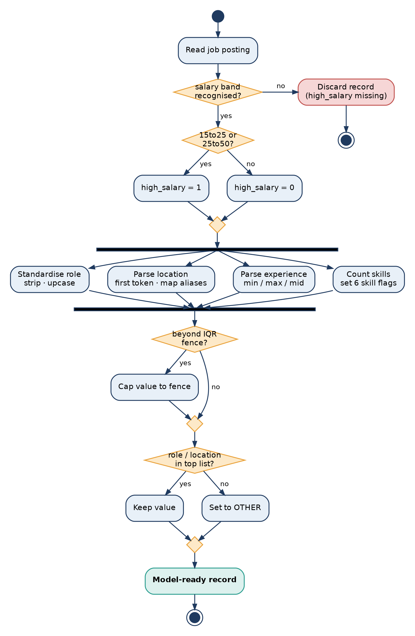
Figure 13. Activity diagram for one job posting, from raw record to model-ready record.

11.4 Sequence diagram: training and scoring run
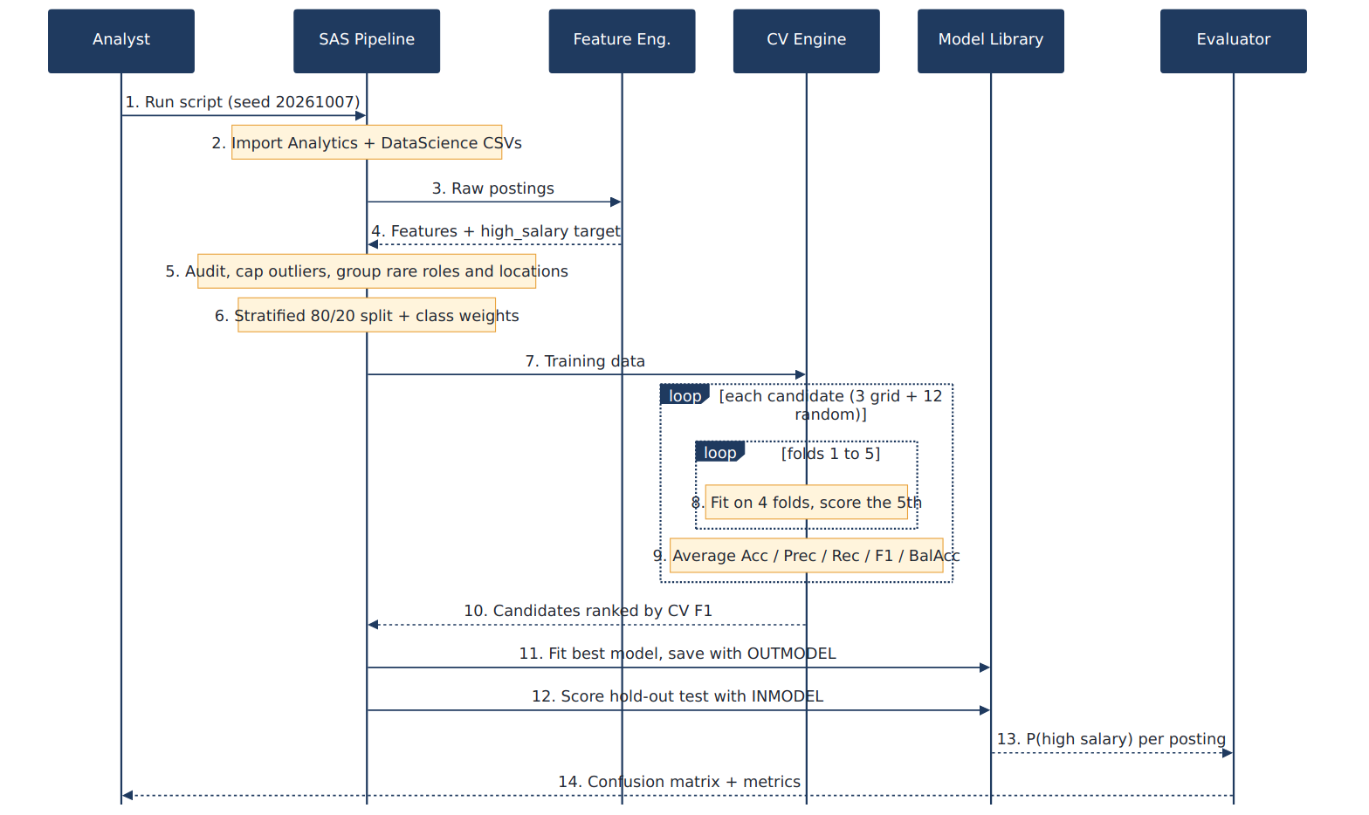
Figure 14. Sequence of interactions during one full run of the pipeline.

12. Using the Model on New Postings
Scoring a new posting reuses the same preparation logic and the saved model, with no retraining:
- Apply the same cleaning and feature engineering (role, location, experience midpoint, skill count and flags).
- Apply the stored IQR fences to cap experience and skill count, and map role and location to the retained top lists or OTHER.
- Run PROC LOGISTIC with INMODEL = models.analytics_high_salary_model and a SCORE statement to obtain P_1, the probability of a high-salary band.
- Label the posting High when P_1 is at or above the selected cutoff, otherwise Lower.

13. Design Rationale
Each major choice in the pipeline was made to fit the data we actually observed in the audit. The table records the decision, the alternative we considered and the reason it was rejected, so reviewers can see the thinking behind the code.
Decision | Alternative considered | Why we chose this
Binary target | Predict one of six salary bands | A high/low split answers the practical question directly and gives 4,526 positive examples, enough for stable estimates. Multi-class bands would leave the top band with only 1,245 postings.
Class weights | Oversample or undersample | Weights keep every real record, add no synthetic rows and leave the test set untouched. They are computed from training counts only.
Cap outliers at IQR fences | Delete outlier rows | Deleting would remove senior postings that are genuine. Capping retains all 15,841 rows while limiting leverage.
Top-20 roles, top-15 locations | One dummy per distinct value | Rare categories create sparse columns and unstable coefficients. Grouping the long tail as OTHER keeps the model compact.
Stratified split and folds | Simple random split | With a 28.6% minority class, random splits can drift. Stratifying keeps the positive rate identical in every part.
Logistic regression | Complex ensembles | It is fast to cross-validate 15 candidates, easy to explain to non-technical judges and outputs probabilities for threshold tuning.
F1 as selection metric | Accuracy | With 71.4% majority class, accuracy rewards ignoring the minority class. F1 balances false alarms and misses.
Search the cutoff, not just features | Fixed 0.50 cutoff | After class weighting the best threshold is not guaranteed to be 0.50, so the randomized search tests 0.40, 0.50 and 0.60.
Single SAS script | Notebook with mixed tools | One script is easy to rerun end to end, with the seed fixed at 20261007 so results repeat.

13.1 Guarding against data leakage
Leakage is the most common reason a hackathon model looks good and then fails, so we checked each route by which salary information could reach the model:
- Target source. The salary band is used only to create high_salary. The salary_band_clean column is never listed among model inputs in any candidate configuration.
- Class weights. Weights are computed after the split, from training counts only.
- Threshold and feature-set choice. Both are chosen on cross-validation folds inside the training data. The 20% test set is scored once, after selection.
- Capping fences. The IQR quartiles are computed on the full labelled table before the split. This is a mild form of preprocessing leakage that affects only three numeric inputs; it is listed as a limitation in section 21 and is easy to remove by computing fences on the training part only.

14. Data Dictionary

14.1 Raw columns
Column | Dataset | Meaning and handling
job_desig | Analytics | Job designation text. Trimmed, whitespace-collapsed and upper-cased; later grouped into top-20 roles.
job_type | Analytics | Employment type. 75.8% missing; set to UNKNOWN when blank and not used in candidate models.
location | Analytics | Comma-separated location text. First city token is kept; Bangalore and Gurgaon aliases are merged.
experience | Analytics | Text range such as 2-5 years. Split into minimum, maximum and midpoint.
salary | Analytics | Categorical salary band: 0to3, 3to6, 6to10, 10to15, 15to25 or 25to50. Source of the target only.
key_skills | Analytics | Comma-separated skill list. Counted, and searched for six named skills.
job_description | Analytics | Free text. Only its length is derived; 22.1% are missing.
job_title | DataScience | Role title; standardised and aggregated for the demand view.
avg_salary, min_salary, max_salary | DataScience | Currency-formatted text. Non-numeric characters are stripped before conversion to numbers; salary range and an order check are derived.
num_of_jobs | DataScience | Number of openings in a record; summed to measure demand by role.

14.2 Derived variables
Variable | Rule | Type | In model?
high_salary | 1 if salary band is 15to25 or 25to50; 0 for the other four bands; missing otherwise | Binary | Target
role_group | job_desig_std if among the 20 most frequent roles, else OTHER | Category | Yes
location_group | location_primary if among the 15 most frequent, else OTHER | Category | G2, G3
experience_mid | Mean of minimum and maximum experience | Numeric | Via cap
experience_cap | experience_mid limited to the IQR fences | Numeric | Yes
experience_group | Buckets 0-1, 2-4, 5-9, 10+ by midpoint | Category | No
skill_count | Number of comma-separated skills; 0 if blank | Numeric | Via cap
skill_count_cap | skill_count limited to the IQR fences | Numeric | G3
python_flag, sql_flag, machine_learning_flag, tableau_flag, powerbi_flag, sas_flag | 1 if the upper-cased skill text contains the keyword | Binary | G3
description_length, description_length_cap | Characters in the stripped description; capped version | Numeric | Audit only
*_missing flags (5) | 1 if description, job type, skills, location or designation is blank | Binary | Audit only
class_weight | N / (2 × class count) from training data | Numeric | Weight
fold | Stratified fold 1 to 5 from round-robin dealing | Integer | CV only

A note on the skill flags. Flags use substring matching on the upper-cased skills text. This is simple and fast, and it also means the SAS flag matches any skill containing the letters SAS. The effect is small in practice, but it is worth knowing when interpreting the coefficient.

15. Evaluation Metrics Explained
All metrics come from the four cells of the confusion matrix. The table gives each formula and applies it to our hold-out result of TP = 667, FP = 492, FN = 238 and TN = 1,771 (3,168 postings, of which 905 are truly high-salary).
Metric | Formula | Worked value
Accuracy | (TP + TN) / total | (667 + 1,771) / 3,168 = 0.770
Precision | TP / (TP + FP) | 667 / 1,159 = 0.575
Recall | TP / (TP + FN) | 667 / 905 = 0.737
Specificity | TN / (TN + FP) | 1,771 / 2,263 = 0.783
F1 | 2 × precision × recall / (precision + recall) | 2 × 0.575 × 0.737 / 1.313 = 0.646
Balanced accuracy | (recall + specificity) / 2 | (0.737 + 0.783) / 2 = 0.760
Miss rate | FN / (TP + FN) | 238 / 905 = 0.263
False alarm rate | FP / (FP + TN) | 492 / 2,263 = 0.217
Lift of positive calls | precision / base rate | 0.575 / 0.286 ≈ 2.0

15.1 Comparison with a do-nothing baseline
A useful sanity check is a model that always predicts the majority class. It looks respectable on accuracy and is useless for the task.
Measure | Always predict lower | Our model | Change
Accuracy | 71.4% | 77.0% | +5.6 points
Recall | 0.0% | 73.7% | +73.7 points
Balanced accuracy | 50.0% | 76.0% | +26.0 points
High-salary jobs found | 0 of 905 | 667 of 905 | +667

15.2 Why F1 drives selection and how to move along the trade-off
Raising the cutoff makes the model more selective, which increases precision and lowers recall. Lowering it does the opposite. Because the randomized search tries three cutoffs, the notice reports the point that gave the best cross-validated F1. A user who wants fewer false alarms, such as a recruiter shortlisting premium roles, can raise the cutoff without retraining because the saved model outputs the probability P_1 for every posting.
Cross-validation versus hold-out. Cross-validated scores guide the choice and the hold-out scores are the honest estimate. A large gap between them would indicate over-fitting to the folds; the final F1 of 0.646 should be compared with the best cv_f1 printed in the ranked search table.

16. Additional System Views

The following diagrams show the same system from four more angles: who uses it, where the pieces run, how the data changes state and how it flows between processes and data sets.

16.1 Use case diagram
Two kinds of users interact with the system. The analyst builds and evaluates the model; downstream users such as recruiters or job seekers consume its predictions and the demand view.
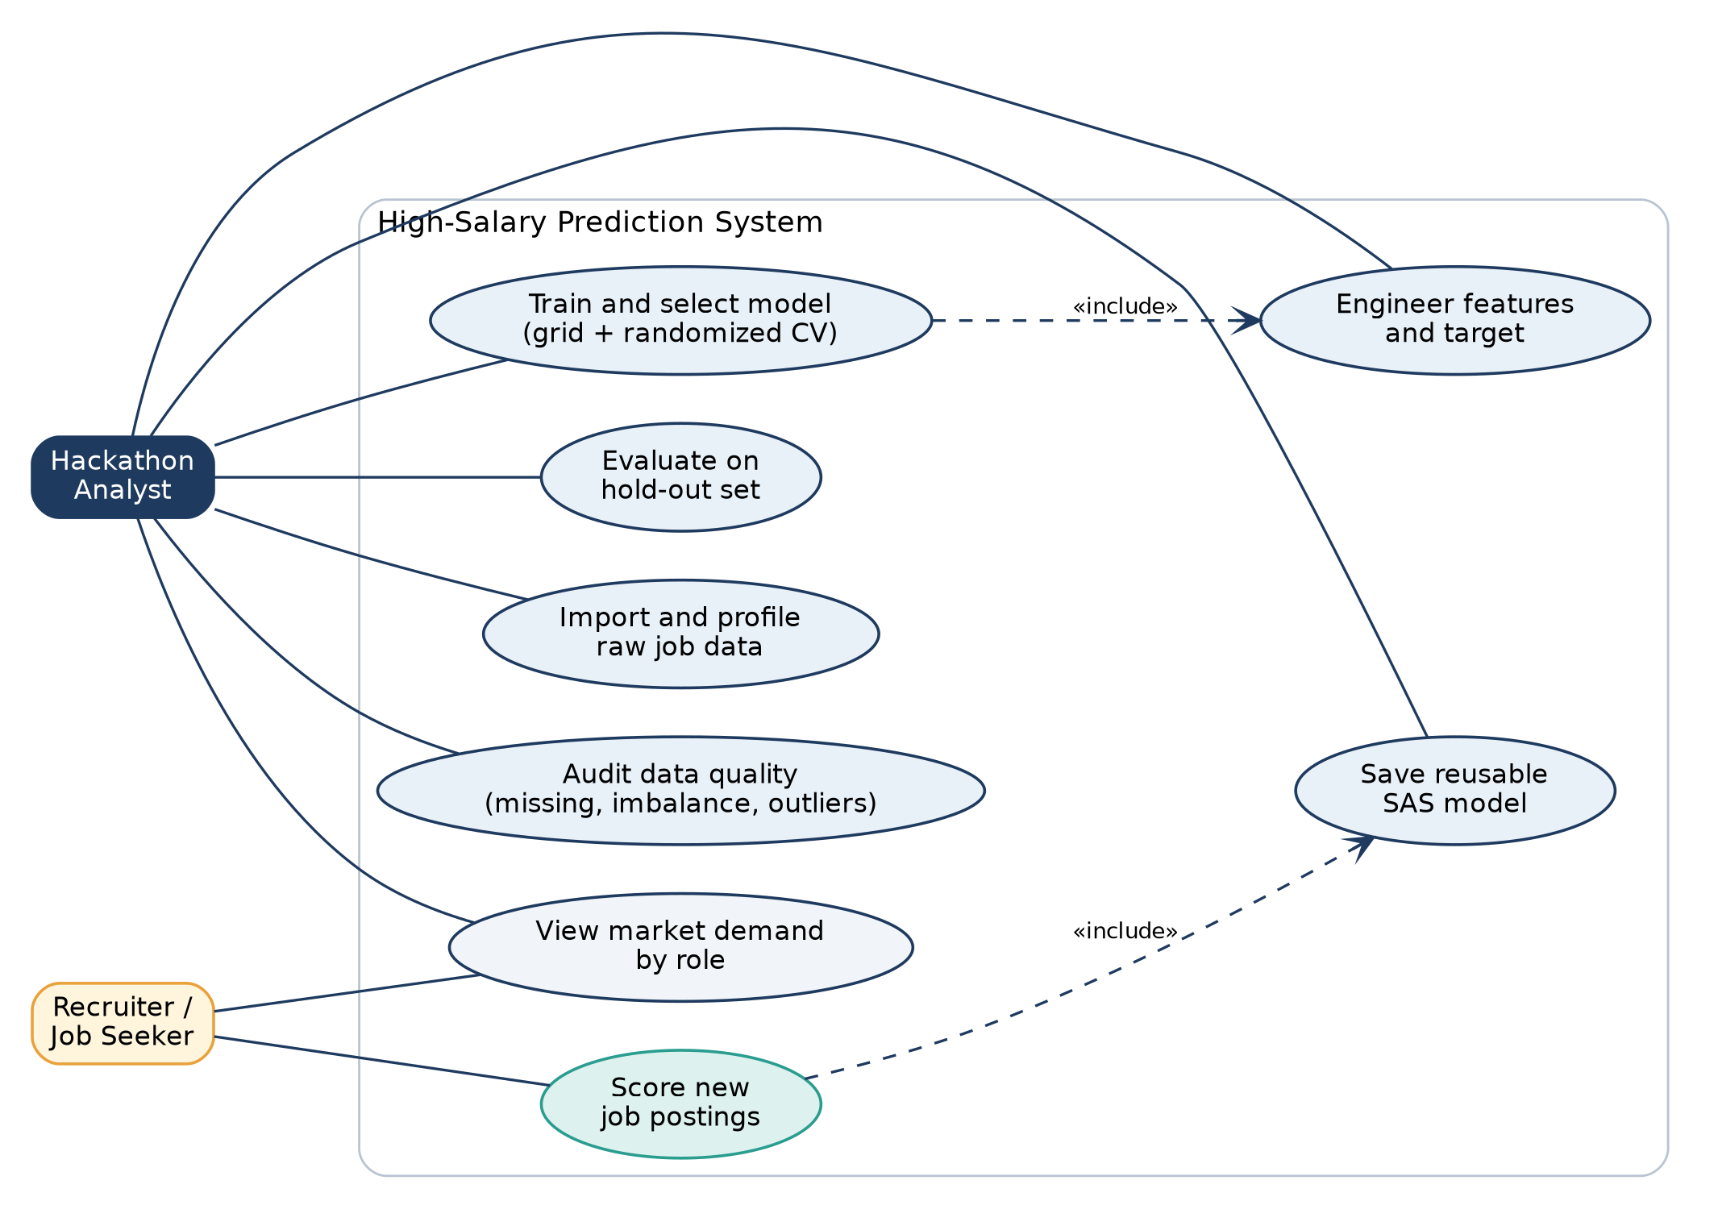
Figure 15. Use cases for the analyst and for downstream users.

16.2 Component and deployment diagram
Everything runs inside one SAS Studio session on the SAS OnDemand server. Inputs and the saved model live in the SAS_Hackathon folder, and the Models folder is exposed to SAS as the models library.
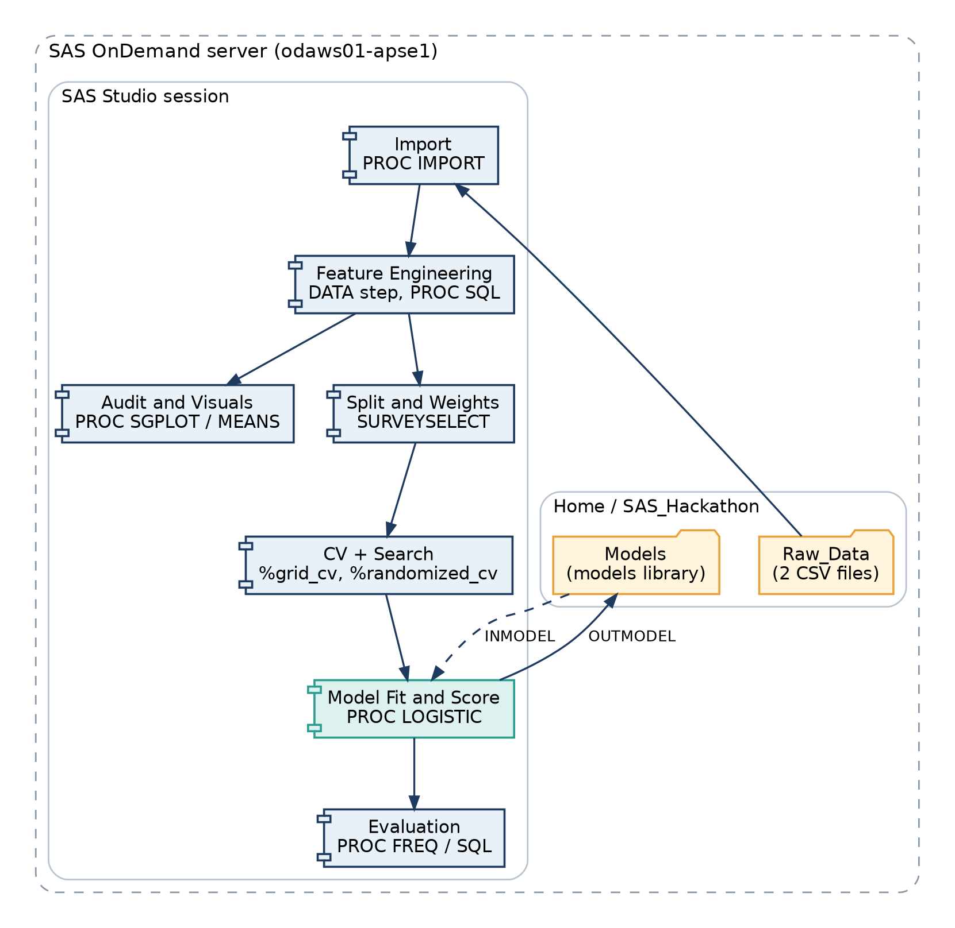
Figure 16. Components of the pipeline and where inputs and the saved model are stored.

16.3 State diagram: lifecycle of the data and model
The dataset passes through well-defined states, and each transition corresponds to a block of the script. The dashed edge shows that new data or a retrain returns the process to the raw state.
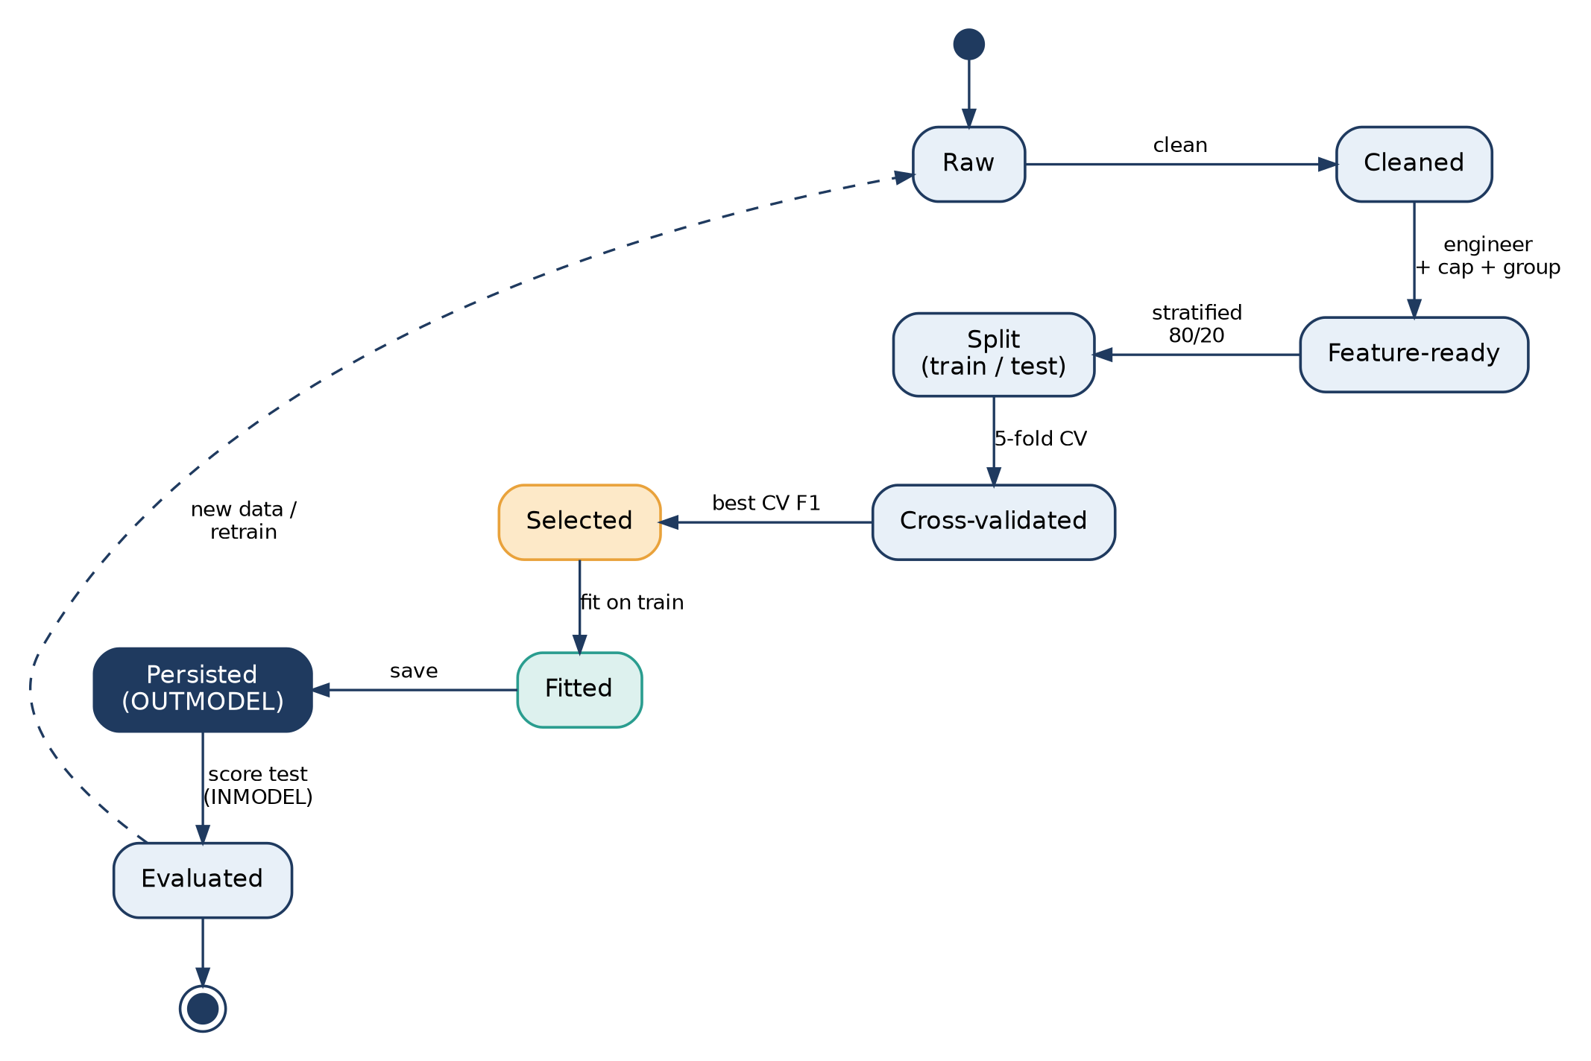
Figure 17. Lifecycle states from raw data to an evaluated, persisted model.

16.4 Data flow diagram
Processes are shown as ellipses and SAS data sets as open boxes. The data set names match those in the script, so a reader can trace any table to the step that creates it.
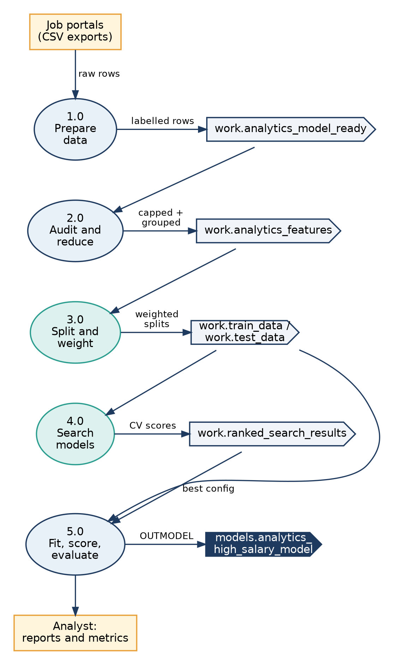
Figure 18. Level-1 data flow from job portal exports to the saved model and reports.

17. Inside the Cross-Validation Macro
The same five-step routine is used for every candidate, which makes grid and randomized results directly comparable. For each fold the macro does the following.
- Split the stratified training data into a training part (the four other folds) and a validation part (the current fold).
- Fit PROC LOGISTIC on the training part with the class weight and the candidate's variable list, and score the validation part in the same step.
- Read P_1, the probability of high salary, and convert it to a class using the candidate's cutoff (0.50 for grid candidates).
- Count true positives, true negatives, false positives and false negatives with PROC SQL.
- Derive accuracy, precision, recall, specificity, F1 and balanced accuracy, and append the row to the results table.
Metric derivation inside the macro (excerpt)
specificity = tn / max(tn + fp, 1);
f1 = 2 * precision * recall / max(precision + recall, .000001);
balanced_accuracy = (recall + specificity) / 2;

Guarding each denominator with max(..., 1) or a tiny constant means a fold with no predicted positives yields a zero score instead of a missing value that would break the averages.

17.1 What each fold looks like
Fold | Used to fit | Used to validate | Class ratio
1 | Folds 2, 3, 4, 5 | Fold 1 | About 71.4% / 28.6% in each part
2 | Folds 1, 3, 4, 5 | Fold 2 | About 71.4% / 28.6% in each part
3 | Folds 1, 2, 4, 5 | Fold 3 | About 71.4% / 28.6% in each part
4 | Folds 1, 2, 3, 5 | Fold 4 | About 71.4% / 28.6% in each part
5 | Folds 1, 2, 3, 4 | Fold 5 | About 71.4% / 28.6% in each part

The pipeline prints a PROC FREQ table of fold by class after assigning folds, so the balance can be confirmed on screen before any model is fitted.

17.2 The randomized search space
Twelve iterations each draw an integer from 1 to 3 for the feature set and another for the cutoff. With three feature sets and three cutoffs there are only nine distinct combinations, so the 12 draws will repeat some of them. This is by design: the search is cheap, seeded and reproducible, and the grid search already guarantees every feature set is evaluated at 0.50.
Draw value | Feature set | Cutoff
1 | G1: experience_cap, role_group | 0.40
2 | G2: G1 + location_group | 0.50
3 | G3: G2 + skill count and six flags | 0.60

18. Risks, Assumptions and Mitigations
Risk or assumption | Impact | Mitigation in this solution
Class imbalance (28.6% positives) | Model may ignore the minority class | Balanced class weights, stratified splits and F1-based selection
Heavy missingness in job type and description | Features carry little signal and may bias results | UNKNOWN category, missing flags kept for audit, fields excluded from candidate models
Outliers in experience and skill count | Extreme values distort coefficients | Capping at 1.5 × IQR fences instead of deleting rows
Rare roles and locations | Sparse dummies and unstable estimates | Top-20 and top-15 grouping with OTHER
Random variation in splits | Results change between runs | Fixed seed 20261007 for sampling, folds and random search
Selection bias from searching 15 candidates | Best CV score is slightly optimistic | Final judgement uses a separate hold-out set scored once
Quartiles computed before the split | Mild preprocessing leakage on three inputs | Disclosed; fences can be recomputed on the training part only
Substring skill matching | Keyword may match unrelated text | Documented; tokenised matching is a planned improvement
Salary bands are self-reported by employers | Labels may be noisy or coarse | Binary grouping of adjacent bands reduces boundary noise
Model drift over time | Pay levels and role names change | Saved model plus rerunnable script allow quick retraining

18.1 Fairness and responsible use
The model uses only job characteristics, not personal attributes, and predicts the salary band of a posting rather than of a person. It should still be used as decision support: a predicted band is a statistical estimate from past postings and should not be used to cap or anchor an individual's pay. Location is the only feature with a geographic dimension, and the top-15 grouping prevents the model from fitting very small areas.

19. Reproducibility and Run Guide

19.1 Parameters
Parameter | Value | Where it is set
Random seed | 20261007 | %let seed in the options block
Number of folds | 5 | %let kfold
Train share | 0.80 | samprate in PROC SURVEYSELECT
IQR multiplier | 1.5 | Outlier fence formulas
Roles retained | 20 | obs=20 on the sorted role frequency table
Locations retained | 15 | obs=15 on the sorted location frequency table
Random search draws | 12 | do iteration=1 to 12
Cutoff options | 0.40, 0.50, 0.60 | Random search configuration
Selection metric | Mean CV F1 | Sort by descending cv_f1

19.2 How to run
- Create the folder SAS_Hackathon in the SAS home directory, with a Raw_Data subfolder holding Analytics Jobs.csv and DataScience Jobs.csv.
- Open the script in SAS Studio and run it from the top. It creates the Models folder and assigns the models library automatically.
- Watch the log for ERROR lines. The macros print the chosen model number, cutoff and search method once ranking finishes.
- Review the printed tables and graphs: record counts, missing values, class balance, outliers, fold balance, ranked search results and final metrics.
- Confirm that models.analytics_high_salary_model exists. PROC CONTENTS in the last step reports on it.

19.3 Expected outputs
Output | Where to find it
Dataset record counts | Step 6 (PROC SQL)
Demand by role table and chart | Steps 10 to 12
Missing-value, salary-band and class-balance charts | Steps 15 to 21
Outlier summary and boxplots | Steps 22 to 29
Fold balance table | Step 45
Grid, random and combined ranked results | Steps 51, 57 and 61
Confusion matrix and final performance | Steps 66 to 68
Actual versus predicted chart | Step 69
Saved model information | Steps 70 and 71

20. Business Value and Illustrative Scoring Walkthrough

20.1 Who benefits
- Job seekers can see whether a posting with a missing or vague salary is likely to sit in the top two bands before investing time in an application.
- Recruiters and HR teams can benchmark a new posting against the market and spot offers that look low for the role, location and skills asked.
- Analytics educators and career platforms can use the skill flags and demand view to show which skills and roles line up with higher pay.

20.2 A worked example (illustrative, not a prediction from our data)
The table below shows how a hypothetical posting is transformed before it reaches the model. The values are invented to show the mechanics; no probability is claimed.
Raw field | Value in the example | Feature produced
job_desig | Senior Data Scientist | job_desig_std = SENIOR DATA SCIENTIST; role_group kept if in the top 20, else OTHER
location | Bangalore, Karnataka | location_primary = BENGALURU; kept if in the top 15
experience | 6-10 | experience_min 6, max 10, mid 8; capped to fences if outside
key_skills | Python, SQL, Machine Learning | skill_count 3; python, sql and machine_learning flags = 1

The saved model then returns P_1. If P_1 is at or above the selected cutoff, the posting is labelled High. Changing the cutoff changes only this last comparison, not the stored model.

20.3 Insights the pipeline already surfaces
- Demand is concentrated in analyst roles: Business Analyst, Data Analyst and Senior Business Analyst dominate the DataScience Jobs demand chart.
- The high-salary class is a clear minority at 28.6%, and the 25to50 band alone is only 1,245 postings, so premium roles are scarce.
- Most postings ask for around five skills, with a median experience of three years, which sets the typical profile against which senior roles stand out.

21. Limitations and Roadmap
- Precision is moderate. About four in ten predicted high-salary postings are false alarms. If false alarms are costlier than misses for a use case, the cutoff can be raised; the saved model already outputs probabilities.
- Sparse fields. Job Type is 75.8% missing and descriptions are 22.1% missing, so they carry little signal today. Enriching them is the cheapest route to better features.
- Model family. Logistic regression is deliberately simple and explainable. Tree-based models and role × experience interactions could capture non-linear pay patterns.
- Binary target. Collapsing six ordered bands into two discards information. An ordinal model could predict the band itself.
- Use of DataScience Jobs. This dataset currently supports demand analysis only; its numeric salaries could help calibrate band boundaries in future work.
- Fence computation. IQR fences use all labelled rows; recomputing them from the training part only would remove the small leakage noted in section 13.1.

21.1 Roadmap
Phase | Action | Expected benefit
Short term | Compute IQR fences on training data only; tokenise skills instead of substring matching | Cleaner validation and more accurate skill flags
Short term | Report ROC and precision-recall curves; add a finer cutoff grid | Better view of the threshold trade-off
Medium term | Add interaction terms such as role × experience band | Capture that seniority pays differently by role
Medium term | Extract skills from job descriptions where present | Recover signal from the 22% missing and short text
Medium term | Compare against tree-based models in SAS | Test whether non-linearity improves F1
Long term | Ordinal model across the six bands | Predict the band, not only high versus lower
Long term | Scheduled retraining and drift monitoring | Keep the model current as pay and titles change

Appendix A. Pipeline Step Map
The script is organised in lettered parts and numbered steps. This map links each step to its purpose so any output in this notice can be traced back to the code.
Steps | Part | What happens
0 to 3 | Setup | Options, seed and fold count, project paths, Models folder, models library
4 to 5 | A. Import | Read DataScience Jobs.csv and Analytics Jobs.csv with PROC IMPORT
6 to 8 | B. Profile | Record counts and variable structure of both data sets
9 to 12 | C. Data Science prep | Clean titles, convert salaries to numbers, validate salary order, build demand table and chart
13 to 14 | D. Feature engineering | Standardise role, type and location; parse experience; build target, skill flags and missing flags; keep valid target rows
15 to 16 | E. Missingness | Missing-value summary table and bar chart
17 to 21 | F. Class imbalance | Salary band distribution, binary class distribution, charts and summary
22 to 29 | G. Outliers | Descriptive statistics, quartiles, IQR flags, capped variables, summary chart and three boxplots
30 to 34 | H. High cardinality | Role and location frequencies, top-20 and top-15 lists, feature table with OTHER grouping
35 to 38 | I. Split | Sort by target, 80/20 stratified sample, train and test sets, distribution checks
39 to 41 | J. Class weights | Training class counts, weight calculation, weight column
42 to 45 | K. Stratified CV | Random order within class, fold assignment, balance check
46 to 51 | L. Grid search | Results table, CV macro, configurations G1 to G3, summary
52 to 57 | M. Randomized search | Draw configurations, display space, CV macro, execute, summary
58 to 62 | N. Selection | Standardise and combine results, rank by cv_f1, select best model and cutoff
63 | O to P. Final model | Final feature set from the best model number; fit and save with OUTMODEL
64 to 65 | Q. Hold-out scoring | Score test set from the saved model; apply cutoff
66 to 68 | R. Evaluation | Confusion matrix, counts, derived metrics, performance table
69 | S. Visual | Actual versus predicted chart
70 to 71 | T. Verification | PROC CONTENTS on the saved model and a final pipeline summary

Appendix B. Additional Code Excerpts

B.1 Missing value summary
PROC SQL missingness table (excerpt)
create table work.missing_summary as
select "Job Description" as variable length=30,
sum(description_missing) as missing_count,
count(*) as total_records
from work.analytics_model_ready
union all
select "Job Type", sum(job_type_missing), count(*)
from work.analytics_model_ready;
/* Key Skills, Location and Designation follow the same pattern */

missing_percent = 100 * missing_count / total_records;

B.2 Data Science salary cleaning
Convert currency text to numbers and validate order (excerpt)
avg_salary_num = input(prxchange('s/[^0-9.]//', -1, strip(avg_salary)), best32.);
min_salary_num = input(prxchange('s/[^0-9.]//', -1, strip(min_salary)), best32.);
max_salary_num = input(prxchange('s/[^0-9.]//', -1, strip(max_salary)), best32.);

invalid_salary_order = 0;
if min_salary_num > avg_salary_num or avg_salary_num > max_salary_num
then invalid_salary_order = 1;

B.3 Role and location grouping
Keep top lists, group the rest as OTHER (excerpt)
case when r.job_desig_std is not null then a.job_desig_std
else "OTHER" end as role_group length=150,
case when l.location_primary is not null then a.location_primary
else "OTHER" end as location_group length=70
from work.analytics_outlier_analysis as a
left join work.top_roles as r on a.job_desig_std = r.job_desig_std
left join work.top_locations as l on a.location_primary = l.location_primary;

B.4 Selecting the best candidate
Rank by cv_f1 and pass the winner to the final model (excerpt)
proc sort data=work.all_search_results out=work.ranked_search_results;
by descending cv_f1;
run;
data work.best_model;
set work.ranked_search_results(obs=1);
run;
data _null_;
set work.best_model;
call symputx("best_model_number", model_number);
call symputx("best_cutoff", cutoff);
call symputx("best_method", search_method);
run;

B.5 Applying the winning cutoff
Predictions on the hold-out set (excerpt)
predicted_probability = P_1;
if not missing(predicted_probability)
and predicted_probability >= &best_cutoff
then predicted_class = 1;
else predicted_class = 0;

Appendix C. Glossary
Term | Meaning
Class imbalance | One outcome is much more common than the other; here 71.4% lower salary against 28.6% high salary.
Stratified sampling | Splitting so each part keeps the same class proportions as the whole.
Cross-validation | Repeatedly training on part of the training data and validating on the rest to estimate performance.
Hold-out set | Data kept aside until the end for a single, unbiased evaluation.
Grid search | Evaluating every candidate in a small, predefined list.
Randomized search | Evaluating randomly drawn candidates from a defined space.
Cutoff (threshold) | Probability above which a posting is labelled high salary.
IQR | Interquartile range, the distance between the 75th and 25th percentiles.
Fence | Q1 minus 1.5 IQR or Q3 plus 1.5 IQR; values beyond it are flagged as potential outliers.
Capping (winsorising) | Replacing an extreme value with the nearest fence rather than deleting the row.
High cardinality | A categorical variable with very many distinct values.
Class weight | A multiplier that makes errors on the minority class count more during fitting.
Logistic regression | A model that estimates the probability of a binary outcome from a weighted sum of inputs.
Precision | Of the postings predicted high salary, the share that truly are.
Recall | Of the truly high-salary postings, the share the model finds.
F1 score | Harmonic mean of precision and recall.
Balanced accuracy | Average of recall on each class; unaffected by class size.
OUTMODEL / INMODEL | SAS options that save a fitted PROC LOGISTIC model and reload it for scoring.

